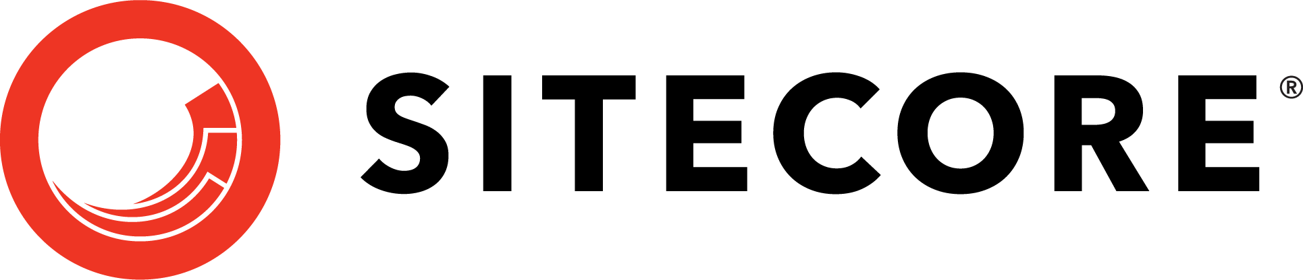



**Sitecore Recruitment**

**Technical Exercise**

**(Selenium)**

Introduction

We want to get a better understanding of (a) the code you produce but also (b) how you go about architecting an extensible solution and finally (c) how you might explain a concept or pattern to others.

Rather than coding something in front of us, which is unrealistic in an interview situation, what we’d like you to do is produce a small solution that demonstrates your skills in writing an automation test with Selenium.

Task Description

Develop a Selenium automation test to validate the following:

* Navigate to <https://www.amazon.com/>
* Type in “laptop” in the search text box
* Click on “Search” button
* Click on the first result
* Upon page loaded, assert that the laptop price is more than $100.

***Estimated Implementation time: ~ 4 hours***

***Important note:******Essential Requirements for the task are algorithm, idea you try to implement, using the most efficient way and code.***

Delivery

* Source code that has been tested and is ready to be compiled and executed. Visual Studio project in ZIP (including bin, obj and packages folder)
* Any manual step in setting up should be scripted in automated manner. (With tools like NodeJS, PowerShell, Visual Studio project file)
* Please deliver this in a publicly available repository like GitHub, BitBucket etc. With documentation about your concerns, decisions, guiding and testing etc.

Implementation Requirements

* Using C# project in Visual Studio
* Using Selenium Web Driver (Chrome or Microsoft Edge)
* Assume web driver is located at C:\Driver\
* Test should be able to execute upon hitting F5
* Test should be completed in less than 30 seconds

NOTE:

The technical exercise is only a starting point for the conversation we’ll have during the interview. You should not try to use all the technologies / practices / patterns you outlined in your CV; you should not try to make this test task more complex than it’s necessary. We’d like to see a piece of code as you would do your daily working task.